Cyclistic Case Study

Increasing Annual Memberships Using Data Insights
Google Data Analytics Capstone Project

Executive Summary
Cyclistic is a bike-share company in Chicago that wants to increase the number of annual memberships. While many riders use single-ride or day passes (casual riders), annual members are more valuable to the company because they generate steady and predictable revenue.
The goal of this project is to understand how annual members and casual riders use Cyclistic bikes differently. By analyzing trip data from _209 ride duration, and usage patterns during the week.
The analysis shows that members mostly ride on weekdays and take shorter trips, while casual riders are more active on weekends and take longer rides. These insights suggest that casual riders use bikes for leisure, while members use them more for daily transportation. Based on these findings, targeted marketing strategies can be designed to encourage casual riders to become annual members.

About the Company
Cyclistic is a Chicago-based bike-share company with thousands of bikes available across hundreds of stations. Riders can unlock a bike from one station and return it to another. The company offers:
- Single-ride passes
- Full-day passes
- Annual memberships
Annual members are important because they provide consistent revenue and are more likely to use the service regularly.

Project Overview
The main objective of this project is to compare how annual members and casual riders use Cyclistic bikes differently.
The analysis focuses on:
- Number of rides
- Ride duration
- Day-of-week usage patterns
By understanding these differences, the company can create better marketing strategies to increase annual memberships.

1. Ask

Business Task
How do annual members and casual riders use Cyclistic bikes differently, and how can these insights help increase memberships?

Key Stakeholders
- Marketing Team
- Director of Marketing
- Executive Team
These stakeholders want clear insights that can support marketing decisions.

2. Prepare

Data Source
The data used for this project comes from publicly available Divvy trip data provided by Motivate International Inc. (Refer Appendix 1 below)
For this analysis, I used:
- Q1 2019 trip data
- Q1 2020 trip data
Each record includes:
- Start time
- End time
- Rider type (member or casual)
- Station information
The data does not include personal information, which protects rider privacy.

3. Process
The analysis was conducted in R using tidyverse packages for cleaning, transformation, and visualization. Python (pandas) was used to validate results and ensure consistency
The data was imported into RStudio for cleaning and analysis.
The following steps were taken:
- Checked for duplicate rows
- Removed missing or incorrect values
- Converted date and time columns into proper format
- Created a new column called ride_length by subtracting start time from end time
- Created a day_of_week column to analyze weekday patterns
Any rides with negative or zero duration were removed to ensure accuracy.
These steps helped prepare the dataset for analysis.

4. Analyze
After cleaning the data, I grouped the rides by rider type and day of the week to compare usage patterns.

Key Observations
- Annual members ride more frequently on weekdays.
- Casual riders are more active on weekends.
- Casual riders generally take longer trips.
- Members tend to take shorter, more frequent rides.
This suggests that:
- Members use bikes for daily transportation or commuting.
- Casual riders use bikes mainly for leisure or recreation.
Although the total number of rides varied slightly between 2019 and 2020, the overall behavioral patterns remained consistent.
These findings help answer the business question and highlight opportunities for converting casual riders into annual members.

5. Share
The results were presented using simple bar charts and summary tables showing:
- Ride frequency by day of week
- Average ride length by rider type
The visualizations clearly show the difference between weekday and weekend patterns.
The findings were explained in clear, simple language so that non-technical stakeholders can understand the results and use them for decision-making.

6. Act – Recommendations
Based on the analysis, the following actions are recommended:

1. Target Frequent Casual Riders
Identify casual riders who use bikes multiple times and offer them membership discounts.

2. Promote Membership During Weekends
Since casual riders are most active on weekends, promotions should be targeted during this time.

3. Highlight Cost Savings
Marketing campaigns should clearly show how frequent riders can save money with an annual membership.

4. Promote Convenience
Emphasize that membership provides flexibility and ease of use for both commuting and leisure.
These strategies can help Cyclistic increase annual memberships and improve long-term revenue stability.

Limitations
This analysis has some limitations:
- Only Q1 2019 and Q1 2020 data were used, so seasonal trends across the full year were not analyzed.
- Q1 2020 may reflect early changes in travel behavior due to the COVID-19 pandemic.
- No demographic data was available for deeper analysis.
Future studies using full-year data and additional customer information would provide more detailed insights.

Conclusion
This project analyzed Cyclistic trip data to understand the differences between annual members and casual riders.
The analysis shows clear behavioral differences:
- Members use bikes mainly for weekday commuting.
- Casual riders use bikes mostly for weekend leisure.
These insights provide a strong foundation for targeted marketing strategies aimed at increasing annual memberships.
By focusing on engaged casual riders and highlighting the benefits of membership, Cyclistic can improve customer retention and long-term profitability.

Cyclistic Case Study - Coding Appendix (R & Python)

PHASE 1: ASK

======================================================================================================

# Business Task:
# Compare how annual members and casual riders use Cyclistic bikes differently.
(No code required — this phase defines the business objective.)
-------------------------------------------------------------------------------------------------------------------------------

PHASE 2: PREPARE

======================================================================================================

Narration:
This step loads the required libraries, imports the Q1 2019 and Q1 2020 datasets, checks their structure, and combines them into a single dataset for analysis.

Code

# Load Required Libraries
library(tidyverse) # For data manipulation and visualization (dplyr + ggplot2)
library(lubridate) # For working with dates and times
library(readr) # For reading CSV files
# Import Q1 2019 and Q1 2020 datasets
df2019 <- read_csv("Divvy_Trips_2019_Q1.csv") # Read 2019 Q1 data
df2020 <- read_csv("Divvy_Trips_2020_Q1.csv") # Read 2020 Q1 data
# Check structure
str(df2019)
str(df2020)
# Standardize column names
df2019 <- df2019 %>% rename_all(~tolower(gsub(" ", "_", .))) # Lowercase and replace spaces with _
df2020 <- df2020 %>% rename_all(~tolower(gsub(" ", "_", .))) # Same for 2020 data

# Combine datasets
all_trips <- bind_rows(df2019, df2020) # Stack the two datasets together into one

Explanation:
library(tidyverse) – Loads a collection of R packages used for data manipulation, transformation, and visualization.
library(lubridate) – Loads functions specifically designed for working with date and time data.
df2019 <- read_csv("Divvy_Trips_2019_Q1.csv") – Imports the Q1 2019 CSV file into R and stores it as a data frame named df2019.
df2020 <- read_csv("Divvy_Trips_2020_Q1.csv") – Imports the Q1 2020 CSV file into R and stores it as a data frame named df2020.
str(df2019) – Displays the structure of the 2019 dataset, including column names and data types.
str(df2020) – Displays the structure of the 2020 dataset to verify its format and consistency.
all_trips <- bind_rows(df2019, df2020) – Combines the two datasets into one single dataset called all_trips for further analysis.
-------------------------------------------------------------------------------------------------------------------------------

PHASE 3: PROCESS

===========================================================================

Data Cleaning

Narration:
This step ensures the dataset is accurate and reliable by removing duplicate records and handling missing values before further analysis.

Code

# Remove duplicates
all_trips <- distinct(all_trips)
# Remove missing values
all_trips <- drop_na(all_trips)
Explanation:
distinct(all_trips) removes duplicate rows to ensure each ride entry is unique.
drop_na(all_trips) removes rows with missing values to improve data quality and prevent errors in analysis.

Format Date Columns

Narration:
This step converts the date and time columns into proper datetime format so they can be used for time-based calculations and analysis

Code

# Convert date columns to proper datetime format

all_trips <- all_trips %>%
mutate(
started_at = ymd_hms(started_at),
ended_at = ymd_hms(ended_at)
)

Explanation:
mutate() modifies existing columns within the dataset.
ymd_hms(started_at) converts the ride start time into a standard datetime format.
ymd_hms(ended_at) converts the ride end time into a standard datetime format.

Create New Variable

Narration:
This step creates new variables that help analyze ride duration and identify usage patterns by day, month, and year.
Code

all_trips <- all_trips %>%

mutate(

ride_length = as.numeric(difftime(ended_at, started_at, units = "mins")),

day_of_week = wday(started_at, label = TRUE, abbr = FALSE),

month = month(started_at, label = TRUE),

year = year(started_at)
)

Explanation:
difftime(ended_at, started_at, units = "mins") calculates ride duration in minutes.
as.numeric() converts the duration into numeric format for analysis.
wday() extracts the full weekday name from the start date.
month() extracts the month from the start date.
year() extracts the year from the start date.

Remove Invalid Ride Durations

Narration:
This step removes rides with zero or negative duration to ensure that only valid trips are included in the analysis.
Code
all_trips <- all_trips %>%
filter(ride_length > 0)

Explanation
filter(ride_length > 0) keeps only rows where ride duration is greater than zero, ensuring data accuracy and consistency.

Saving Combined Dataset

write_csv(all_trips, "combined_trips.csv")

-------------------------------------------------------------------------------------------------------------------------------

PHASE 4: ANALYZE

==========================================================================

4.1 Summary Statistics by Rider Type
Narration
This step calculates key statistical measures to compare ride behavior between annual members and casual riders, including total rides and ride duration metrics.

Code
summary_stats <- all_trips %>%
group_by(member_casual) %>%
summarise(
total_rides = n(),
avg_ride_length = mean(ride_length),
median_ride_length = median(ride_length),
max_ride_length = max(ride_length),
min_ride_length = min(ride_length),
.groups = "drop"
)

summary_stats

Explanation
group_by(member_casual) groups the dataset by rider type (member or casual).
summarise() calculates summary statistics for each group.
n() counts the total number of rides.
mean() calculates the average ride length.
median() calculates the middle value of ride length.
max() identifies the longest ride.
min() identifies the shortest ride.
.groups = "drop" removes grouping after summarization.
summary_stats displays the resulting summary table.

4.2 Ride Frequency by Day of Week
Narration
This step analyzes how ride frequency varies by day of the week for members and casual riders.
Code
ride_frequency <- all_trips %>%
group_by(member_casual, day_of_week) %>%
summarise(total_rides = n(), .groups = "drop")

ride_frequency

Explanation
group_by(member_casual, day_of_week) groups data by rider type and weekday.
summarise(total_rides = n()) counts the number of rides for each group.
.groups = "drop" removes grouping after calculation.
ride_frequency displays the frequency table.

4.3 Average Ride Length by Day
Narration
This step calculates the average ride duration by rider type for each day of the week to identify usage patterns.
Code
avg_duration <- all_trips %>%
group_by(member_casual, day_of_week) %>%
summarise(
avg_ride_length = mean(ride_length),
.groups = "drop"
)

avg_duration

Explanation
group_by(member_casual, day_of_week) groups rides by rider type and weekday.
mean(ride_length) calculates the average ride duration for each group.
.groups = "drop" removes grouping after summarization.
avg_duration displays the table of average ride lengths.

-------------------------------------------------------------------------------------------------------------------------------

PHASE 5: SHARE (Visualization)

Total Rides per Month

Narration
To compare usage patterns between casual riders and annual members, a bar chart was created showing the total number of rides taken each month. Visualization helps identify differences in riding behavior between the two groups. Using ggplot2, the chart presents monthly ride totals clearly.
Code
ggplot(summary_data, aes(x = month, y = total_rides, fill = member_casual)) +
# Initialize a ggplot chart using the dataset "summary_data"; month is mapped to x-axis, total_rides to y-axis, and fill color represents rider type
geom_col(position = "dodge") +
# Create side-by-side bar columns to compare total rides between casual and member riders each month
labs(title = "Total Rides per Month by Rider Type", x = "Month", y = "Total Rides") +
# Add a descriptive chart title and axis labels for clarity
theme_minimal()
# Apply a minimal, clean theme to improve readability and focus on the data
ggsave("Total_Rides_per_Month.png")
# Save the chart as a PNG image file in the working directory for use in reports or presentations

Explanation
This chart visualizes the total number of rides taken each month by casual riders and annual members. The side-by-side bar chart allows easy comparison of ride frequency between the two rider types. Using a clean theme and clear axis labels improves readability, and saving the chart as a PNG

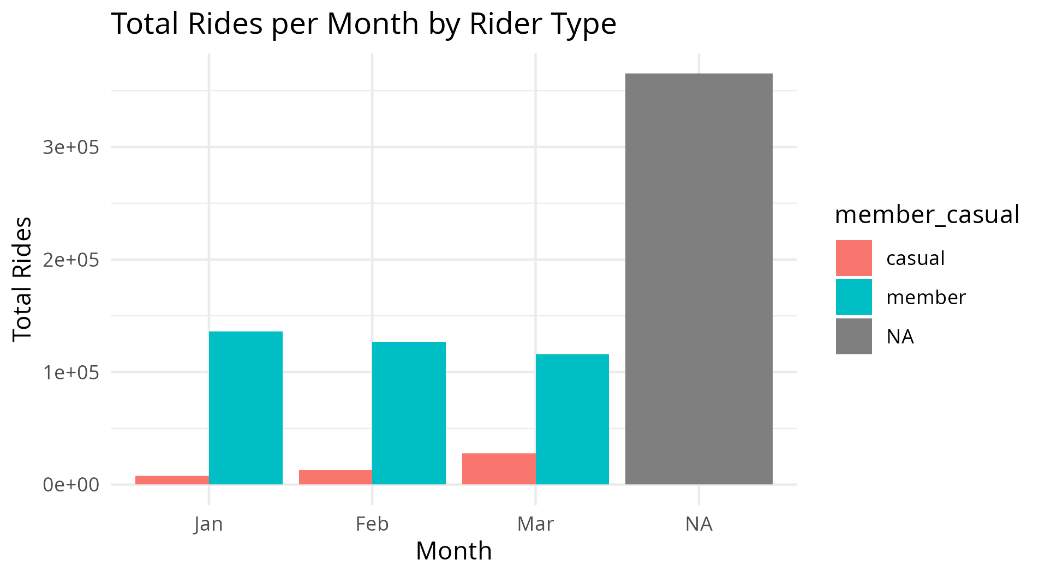

Average Ride Length per Month by Rider Type

Narration
This script generates a line chart showing the average ride length per month for casual riders and annual members. The visualization highlights trends in ride duration over time, making it easy to compare riding behavior between the two groups. The chart is saved as a PNG file for inclusion in reports or presentations.
Code
ggplot(summary_data, aes(x = month, y = average_ride_length, color = member_casual, group = member_casual)) +
# Initialize a ggplot chart using the dataset "summary_data"; set month on the x-axis, average_ride_length on the y-axis, color bars by rider type, and group lines by rider type
geom_line(size = 1) +
# Draw a line connecting the monthly average ride lengths for each rider type; size = 1 sets the thickness of the line
geom_point(size = 2) +
# Add points on the line to highlight individual monthly values; size = 2 sets the size of the points labs(title = "Average Ride Length per Month", x = "Month", y = "Average Ride Length (minutes)") +
# Add a descriptive chart title and label the x-axis as "Month" and y-axis as "Average Ride Length (minutes)"
theme_minimal()
# Apply a clean, minimal theme to make the chart visually simple and easy to read
ggsave("Average_Ride_Length_per_Month.png")
# Save the completed line chart as a PNG image file in the working directory for inclusion in reports or presentations
Explanation
The script generates a line chart showing the average ride length per month for casual riders and annual members using the summary_data dataset.
- The ggplot() function initializes the chart and maps month to the x-axis, average ride length to the y-axis, and uses color and grouping by rider type to differentiate lines.
- geom_line() draws lines connecting monthly averages for each rider group, showing trends over time.
- geom_point() adds points on the lines to highlight individual month values.
- labs() adds a descriptive title and labels the axes for clarity.
- theme_minimal() applies a clean and simple visual style, making the chart easy to read.
- ggsave() saves the chart as a PNG file, which can be included in reports or presentations to communicate insights from the analysis.
This chart allows comparison of riding patterns, revealing whether casual or member riders take longer rides in different months.
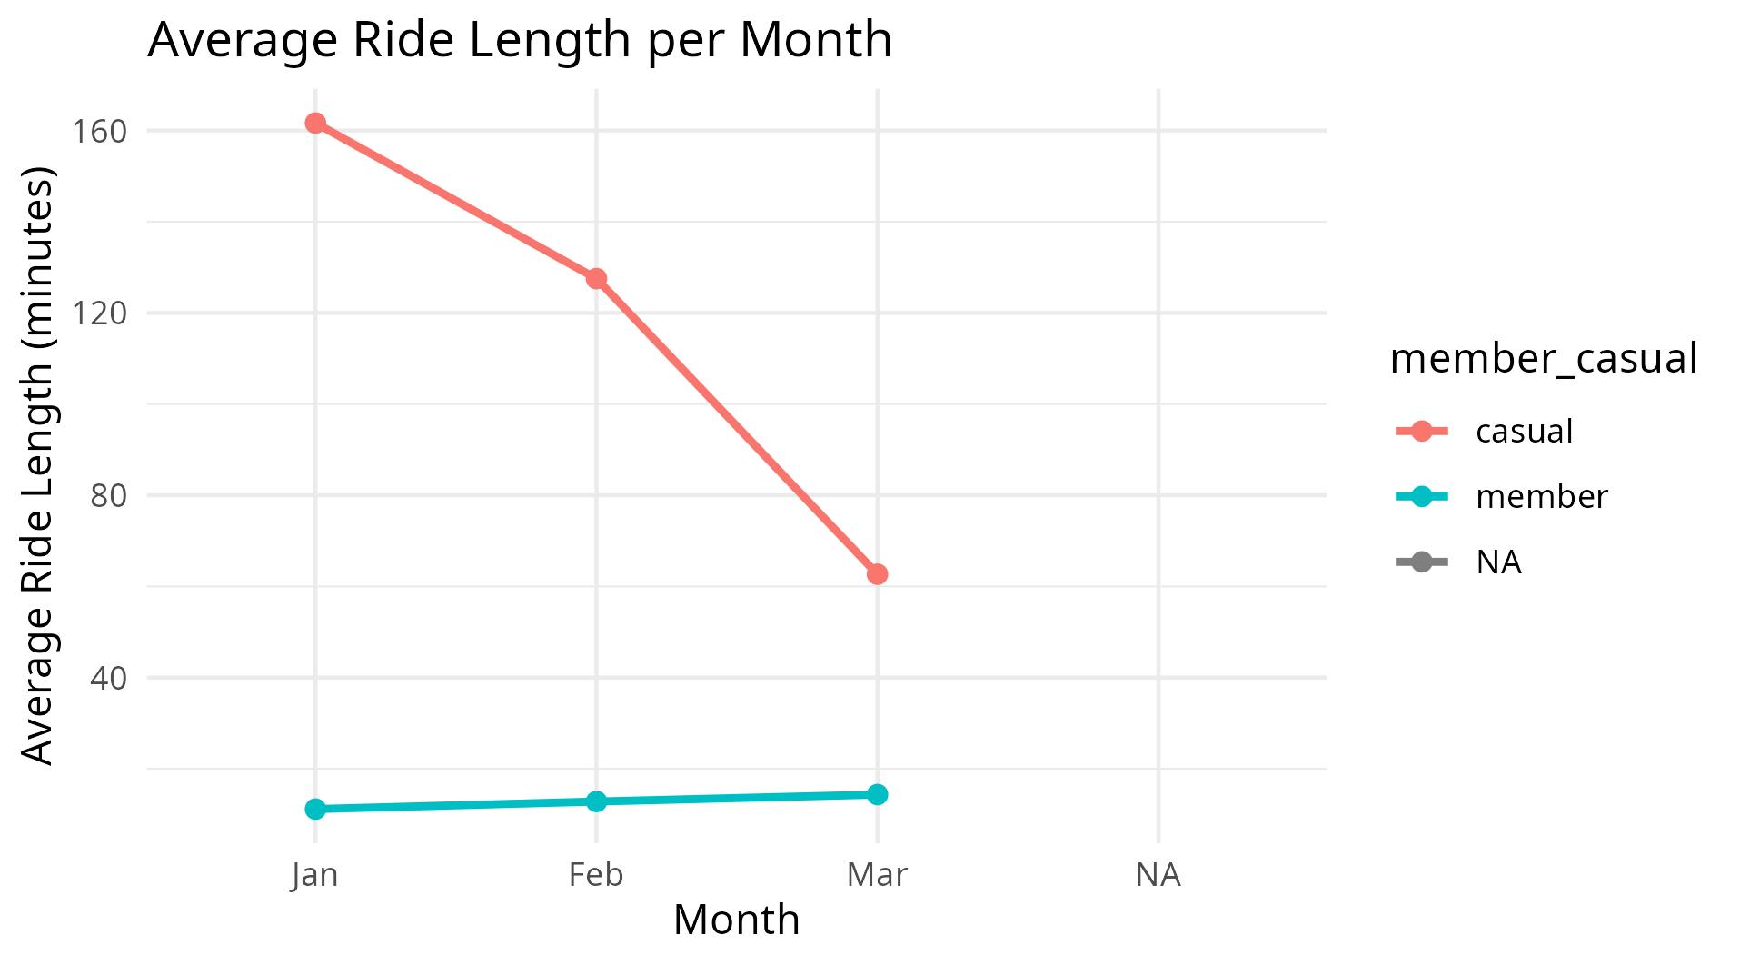

Ride Length Distribution by Rider Type

Narration
This script creates a boxplot to visualize the distribution of ride lengths for casual riders and annual members using the all_trips dataset. The chart highlights the median, spread, and outliers of ride durations, allowing easy comparison between the two rider types. The y-axis is limited to 0–100 minutes for clarity, and the chart is saved as a PNG.

Code

ggplot(all_trips, aes(x = member_casual, y = ride_length_minutes, fill = member_casual)) + # Boxplot settings geom_boxplot() + # Draw boxplot coord_cartesian(ylim = c(0, 100)) + # Limit y-axis to 0-100 minutes for better visibility labs(title = "Ride Length Distribution by Rider Type", x = "Rider Type", y = "Ride Length (minutes)") + theme_minimal() ggsave("Ride_Length_Boxplot.png") # Save chart as PNG

Explanation
The script generates a boxplot to compare ride length distributions between casual riders and annual members.
- ggplot(all_trips, aes(x = member_casual, y = ride_length_minutes, fill = member_casual)) initializes the chart using the all_trips dataset, mapping rider type to the x-axis, ride length to the y-axis, and coloring the boxes by rider type.
- geom_boxplot() draws the boxplots, showing the median, quartiles, and outliers of ride lengths for each rider type.
- coord_cartesian(ylim = c(0, 100)) limits the y-axis to 0–100 minutes to focus on the most common ride durations and improve readability.
- labs(title = "Ride Length Distribution by Rider Type", x = "Rider Type", y = "Ride Length (minutes)") adds a descriptive title and axis labels.
- theme_minimal() applies a clean, simple theme to make the chart easier to read.
- ggsave("Ride_Length_Boxplot.png") saves the chart as a PNG image, ready for use in reports or presentations.

-------------------------------------------------------------------------------------------------------------------------------

PHASE 6: ACT (Business Insight Support Code)

==========================================================================

Identify Peak Casual Riding Days

Narration
This step identifies the days of the week when casual riders use the bike service most frequently. Understanding these patterns can help Cyclistic target casual riders with promotions encouraging them to become annual members.
Code
casual_usage <- all_trips %>%
filter(member_casual == "casual") %>%
group_by(day_of_week) %>%
summarise(total_rides = n(), .groups = "drop") %>%
arrange(desc(total_rides))

casual_usage

Explanation

filter(member_casual == "casual") selects only rides taken by casual users.
group_by(day_of_week) groups the dataset by the day the ride occurred.
summarise(total_rides = n()) counts the number of rides taken by casual riders on each day.
.groups = "drop" removes grouping after summarization.
arrange(desc(total_rides)) sorts the results to show the busiest casual riding days first.
casual_usage displays the resulting summary table.

-------------------------------------------------------------------------------------------------------------------------------

Python Script for Result Validation
The primary analysis for this case study was conducted in R. A short Python script using the Pandas library was used only to validate summary statistics and ensure the results generated in R were consistent.

Jupyter Notebook to validate results:

import pandas as pd

# Load cleaned dataset
df = pd.read_csv("cyclistic_cleaned_data.csv")

Loads the cleaned dataset from a CSV file into Python using the pandas library and stores it in a DataFrame named df for further analysis.

# Basic validation
print(df.shape)

Displays the number of rows and columns in the dataset, helping verify the size of the DataFrame after loading.

print(df.isnull().sum())

Checks for missing values in each column and shows the total number of null entries per column to ensure data completeness

# Summary statistics
print(df.groupby('member_casual')['ride_length']
.agg(['count','mean','median','max','min']))

Groups the data into members and casual riders, then calculates important ride statistics for each group — including the total number of rides (count), average ride length (mean), typical ride length (median), longest ride (max), and shortest ride (min).

# Day of week frequency
print(df.groupby(['member_casual','day_of_week']).size())
- df.groupby(['member_casual','day_of_week'])
  - Groups DataFrame df by two columns: 'member_casual' and 'day_of_week'.
  - 'member_casual' - distinguishes between membership types (e.g., "member" vs. "casual").
  - 'day_of_week' indicates which day each ride took place.
- .size()
  - Counts the number of rows (rides) in each group.
  - How many rides occurred for each combination of member type and day of the week.
- print()
  - Displays the result in the console.
Next Page

